Course Name: | Web Development Laboratory (316U01L306) | Semester: | III
Date of Performance: | 10/10/26 | DIV/ Batch No: | A1
Student Name: | Mrudul Bhagwat | Roll No: | 20

Experiment No: 6
Title
Form Validation using jQuery for an AI-based Smart Irrigation Advisory Web Portal
Aim of the Experiment
To design and implement client-side form validation using jQuery for the farmer registration form of an AI-based Smart Irrigation Advisory System, ensuring that user-entered data such as name, mobile number, email, plot ID, soil moisture, crop stage, irrigation method, and date is complete, valid, and meaningful before form submission.
Objectives of the Experiment
• To create an interactive HTML form for collecting farmer and farm information.
• To use jQuery to validate text, numeric, email, date, and selection fields.
• To use regular expressions with jQuery for validating mobile numbers, email addresses, and plot IDs.
• To display meaningful error messages and prevent submission when invalid data is entered.
• To apply jQuery form validation to a real-world agriculture use case involving farmer and farm registration.
COs to be achieved
CO1: Developing webpages using HTML, CSS, JavaScript and jQuery.
Books / Journals / Websites references
1. jQuery API Documentation – Form events, selectors and DOM manipulation.
2. W3Schools – jQuery and HTML Forms.
3. KisanSaathi deployed portal: https://smartirrigation-brown.vercel.app/registration.html.
Theory
Form validation is the process of checking whether the information entered by a user satisfies the required rules before it is submitted or processed. Validation improves data quality, usability, and reliability.
jQuery is a JavaScript library that simplifies DOM selection, event handling, and manipulation. For client-side form validation, jQuery can select form elements using selectors, read their values using val(), remove extra spaces using trim(), test patterns using regular expressions, add or remove CSS classes, display error messages, and control form submission through the submit event.
Common validation rules include checking for empty fields, minimum and maximum length, valid email format, valid mobile number, acceptable numeric ranges, selected options, and valid dates. Regular expressions are useful for validating structured values such as mobile numbers, email addresses, and plot IDs.
In this experiment, the deployed KisanSaathi farmer registration form uses jQuery 4.0.0 for browser-side validation. The library is bundled locally, and the custom validation script checks user input before displaying a ready-to-submit status.
Problem Statement
"jQuery Form Validation for Farmer Registration"
Develop a web-based farmer registration form for the Smart Irrigation Advisory System. The form should collect essential farmer and farm information and use jQuery to validate the entered values before submission. Invalid or incomplete data must be identified and appropriate error messages must be displayed to the user.
Task 1: Create the Farmer Registration Form
Scenario
Design a registration form for farmers who will use the AI-based Smart Irrigation Advisory Web Portal.
Requirements
• Create fields for Farmer Name, Mobile Number, Email, Plot ID, Village, Crop Stage, Soil Type, Irrigation Method, Soil Moisture (%), Registration Date and Farm Photo.
• Use <form>, <label>, <input>, <select>, <option>, <fieldset> and <legend>.
• Include the jQuery library and provide Submit and Reset buttons.
• Assign unique id and name attributes to all fields.
Concepts Tested
• HTML Forms
• Form controls and jQuery selectors
• jQuery DOM manipulation
Deliverable: registration.html
Task 2: Validate Required Text Fields using jQuery
Scenario
Ensure that essential farmer and farm information is not left blank.
Requirements
• Check that Farmer Name, Plot ID and Village are not empty using jQuery.
• Remove leading and trailing spaces using $.trim() or JavaScript trim() through jQuery event handling.
• Validate that Farmer Name contains alphabetic characters and spaces only.
• Display an error message beside each invalid field and highlight the invalid field using jQuery.
Concepts Tested
• jQuery selectors and val()
• String validation
• Required-field validation and DOM manipulation
Deliverable: registration.html
Task 3: Validate Mobile Number and Email using jQuery
Scenario
Verify that the farmer's contact information follows the expected format.
Requirements
• Validate a 10-digit Indian mobile number using a suitable regular expression.
• Validate the email address using a regular expression.
• Display specific messages for invalid mobile number and email.
• Do not allow the form to submit until both fields are valid.
Concepts Tested
• jQuery event handling
• Regular expressions
• Form submit event
Deliverable: registration.html
Code: GitHub Repository :https://github.com/mrudul2505/AI-based-Smart-Irrigation-Advisory-Kisan-Sathi-
Live Website : https://smartirrigation-brown.vercel.app/
registration.html loads the local jQuery library before the custom validation script. The following JavaScript listing matches the deployed js/registration-validation.js file.
<!-- registration.html: script loading order -->
<script src="js/vendor/jquery-4.0.0.min.js" defer></script>
<script src="js/registration-validation.js" defer></script>

/* js/registration-validation.js: complete custom script */
/* Farmer registration validation using the bundled jQuery library. */
jQuery(function ($) {
const $form = $('#registration-form');
if (!$form.length) return;

const $success = $form.find('#form-success');
const $date = $form.find('#date');
const cropStages = ['germination', 'tillering', 'grand-growth', 'maturity'];
const soilTypes = ['black-cotton', 'red-laterite', 'alluvial', 'sandy', 'clay'];
const irrigationMethods = ['drip', 'furrow', 'sprinkler', 'flood'];

// Use the farmer's local calendar date instead of a UTC ISO timestamp.
function today() {
const now = new Date();
return [now.getFullYear(), String(now.getMonth() + 1).padStart(2, '0'),
String(now.getDate()).padStart(2, '0')].join('-');
}

$date.attr('max', today());
$form.find('input[name="irrigation"]').attr('aria-describedby', 'irrigation-error');

const rules = {
name: value => {
if (!value) return 'Name is required.';
if (!/^[A-Za-z ]+$/.test(value)) return 'Enter a name using letters and spaces only.';
return '';
},
mobile: value => {
if (!value) return 'Mobile number is required.';
if (!/^[6-9]\d{9}$/.test(value)) return 'Enter a valid 10-digit Indian mobile number.';
return '';
},
email: value => {
if (!value) return 'Email address is required.';
if (!/^[^\s@]+@[^\s@]+\.[^\s@]+$/.test(value)) return 'Enter a valid email address.';
return '';
},
village: value => value ? '' : 'Village is required.',
plotid: value => {
if (!value) return 'Plot ID is required.';
if (!/^PLOT-[A-Z0-9]+$/.test(value)) return 'Enter a Plot ID such as PLOT-A or PLOT-12.';
return '';
},
cropstage: value => cropStages.includes(value) ? '' : 'Select a crop stage.',
soiltype: value => soilTypes.includes(value) ? '' : 'Select a soil type.',
irrigation: value => irrigationMethods.includes(value) ? '' : 'Choose an irrigation method.',
moisture: value => {
if (!value) return 'Soil moisture is required.';
const amount = Number(value);
if (!Number.isFinite(amount) || amount < 0 || amount > 100) {
return 'Enter soil moisture between 0 and 100.';
}
return '';
},
date: value => {
if (!value) return 'Date is required.';
if (!/^\d{4}-\d{2}-\d{2}$/.test(value)) return 'Enter a valid registration date.';
const [year, month, day] = value.split('-').map(Number);
const selected = new Date(year, month - 1, day);
if (selected.getFullYear() !== year || selected.getMonth() !== month - 1 || selected.getDate() !== day) {
return 'Enter a valid registration date.';
}
if (value > today()) return 'Registration date cannot be in the future.';
return '';
}
};

function setFieldState(id) {
const $targets = id === 'irrigation'
? $form.find('input[name="irrigation"]')
: $form.find('#' + id);
const value = id === 'irrigation'
? $targets.filter(':checked').val()
: $targets.val();
const message = rules[id](String(value ?? '').trim());
$targets.toggleClass('is-invalid', Boolean(message))
.attr('aria-invalid', String(Boolean(message)));
$form.find('#' + id + '-error').text(message);
return message === '';
}

$form.on('input change', 'input, select', function () {
$success.prop('hidden', true).text('');
const id = this.name === 'irrigation' ? 'irrigation' : this.id;
if (Object.prototype.hasOwnProperty.call(rules, id)) setFieldState(id);
});

$form.on('submit', function (event) {
event.preventDefault();
$date.attr('max', today());
// Run every rule before combining results so every invalid field is shown.
const results = Object.keys(rules).map(setFieldState);
const valid = results.every(Boolean);
$success.prop('hidden', !valid).text(valid
? 'Registration details are valid. Farmer registration is ready to be submitted.'
: '');
if (!valid) $form.find('.is-invalid').first().trigger('focus');
});

$form.on('reset', function () {
$form.find('.field-error').text('');
$form.find('[aria-invalid]').removeClass('is-invalid').removeAttr('aria-invalid');
$success.prop('hidden', true).text('');
$date.attr('max', today());
});
});
Output / Screenshot:
Live screenshots from https://smartirrigation-brown.vercel.app/registration.html, captured on 22 October 2026, show the registration form, invalid sample inputs, and the ready-to-submit message after correction.
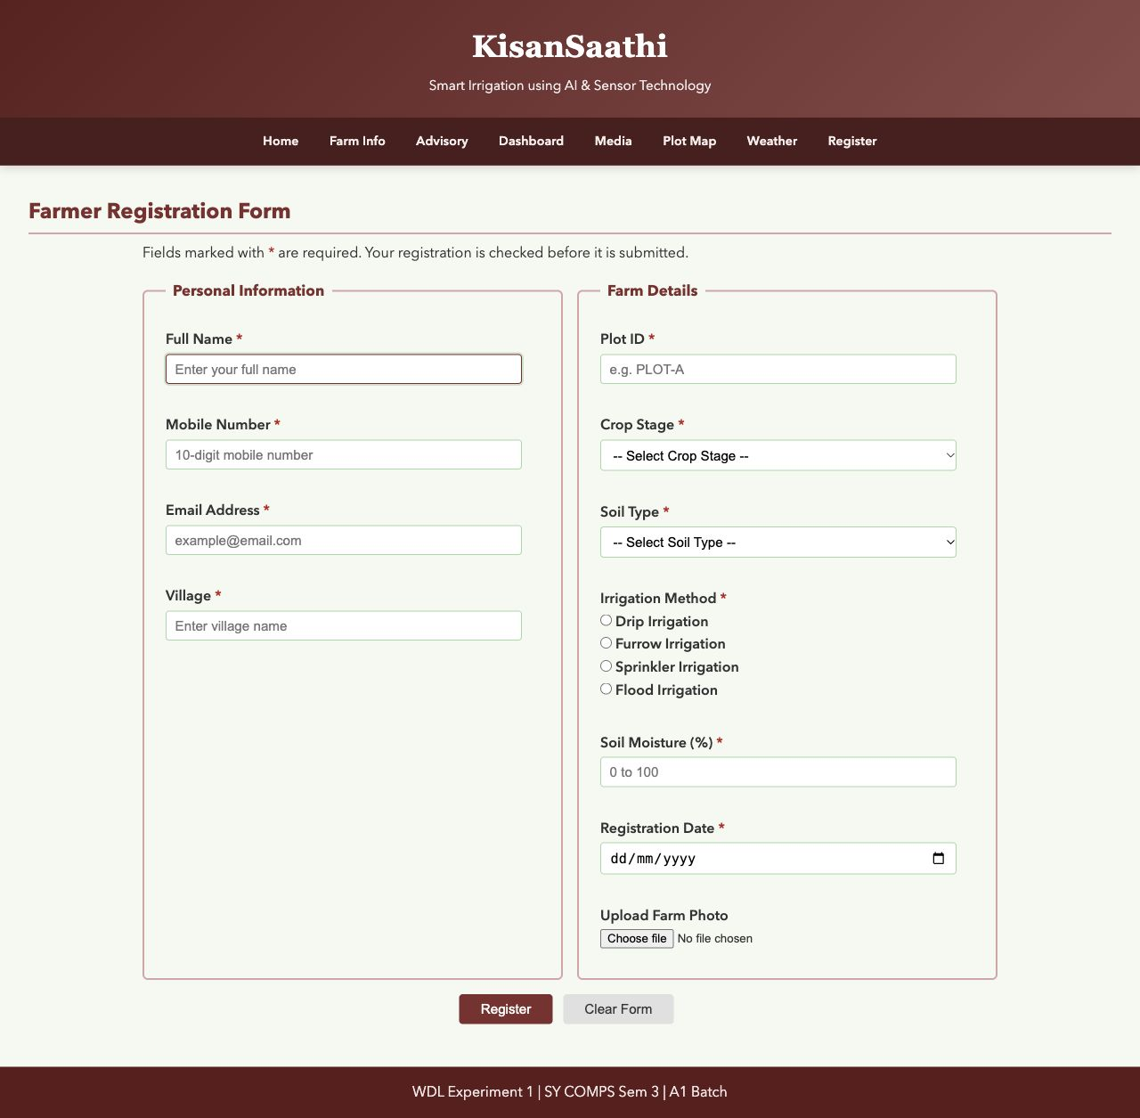
Figure 1 The deployed farmer registration form before data entry.
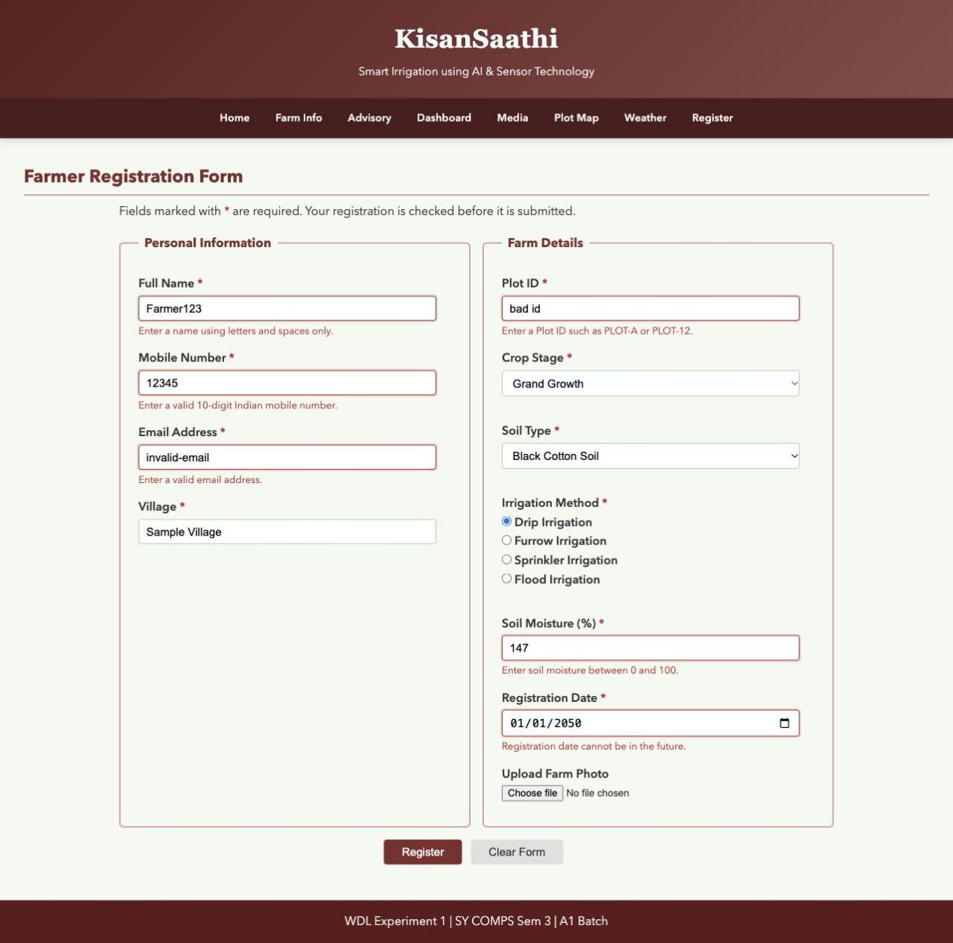
Figure 2 jQuery displays actual name, mobile, email, Plot ID, moisture and future-date errors.
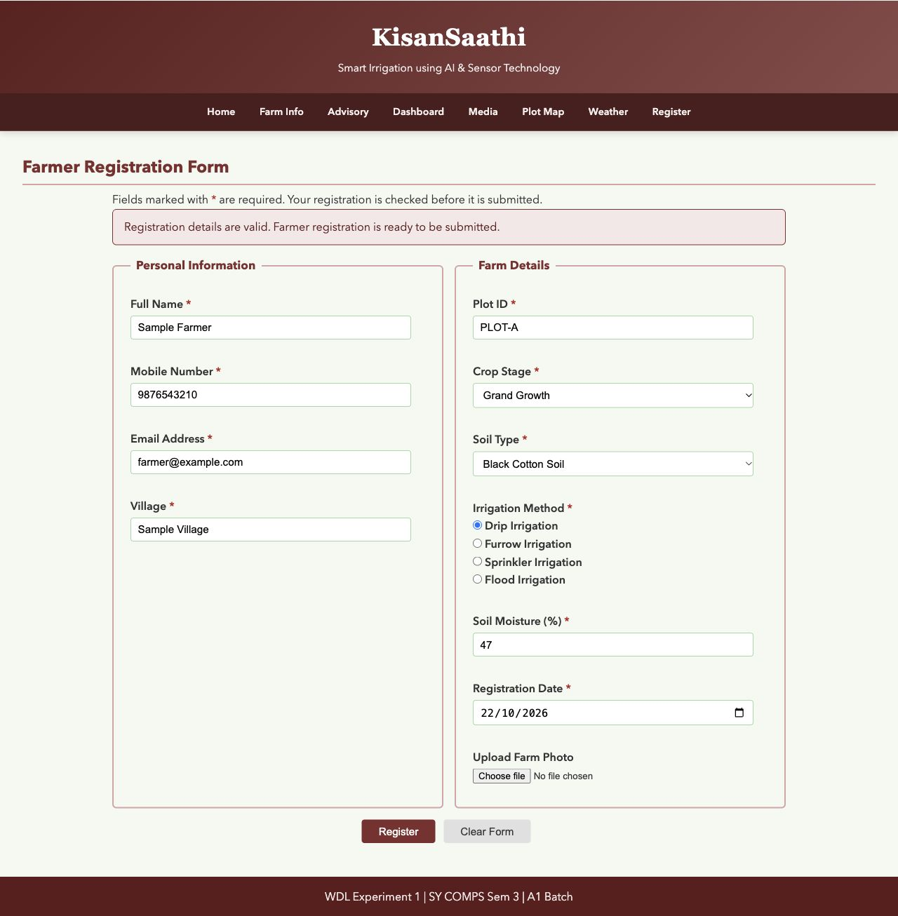
Figure 3 Valid sample data displays the ready-to-submit status. No server registration is saved.
Conclusion and Discussion:
The experiment implemented client-side form validation using jQuery selectors, val(), on(), text(), toggleClass(), attr() and prop(). Required values, alphabetic names, Indian mobile numbers, email format, Plot IDs, crop and soil selections, irrigation method, soil moisture from 0 to 100, and dates up to the local current date are checked. All rules run on submit; invalid controls are highlighted and focused. Input changes clear the old success status, and Clear Form removes validation messages and highlights.

